Product Documentation

iManage Lite

copyright © Automateitops. All rights reserved. http://help.automateitops.com/

The information contained in this document is subject to change without notice. This document contains proprietary information which is protected by copyright. All rights are reserved. No part of this document may be photocopied, reproduced, or translated to another language without the prior written consent of Automateitops.
Table of Contents
Introduction 3
Key Features 4
Monitoring Capabilities 5
Application Servers 5
Database Servers 5
Middleware / Portal 6
Virtualization / Cloud Solutions 6
Services 6
iManage Implementation Readiness Recommendations for Professional Customers 7
Readiness Overview 7
1. About the IManage solution 7
Agent and Agentless 7
2. Logging into your account 8
Logging into iManage 8
Adding servers into monitoring Dashboard. 9
Real-time-server performance monitor dashboard 10
Monitoring server availability and health 12
Web server monitoring and application performance 13
Services monitoring 13
URL and website monitoring 13

Introduction

Automated system operations (ASO) is the set of software and hardware that allows IT Infrastructure computer systems, network devices or machines to function without any manual intervention. Automated system operations are also known as lights-out operations.

“Simplify and Automate” the new innovative way to run your IT & Business operations. Built on Cloud, Artificial Intelligence, Blockchain and mobile technologies, iManage Pro and iManage Lite versions can de-risk and remove the need for manual errors, system, or application failures and any human dependencies that can be delayed or impact your business operations and IT Infrastructure. A combination of cloud-based collectors to automatically detect, monitor, alert and then initiate based on AI techniques to silently resolves any threat, attack, or failure on your entire IT infrastructure. With automated discovery of all resources, you’ll have full-stack visibility across all cloud, hybrid, and on-premises environments in a fraction of time. Leave the manual configuration and expensive hardware behind and step into the future of AI enabled infrastructure management and automation.

The product supports multiple application types such as web applications, application servers, web servers, databases, network services, servers, middleware and messaging components, ERP software, virtual systems, and cloud resources. It provides remote business management to the applications or resources in the network. It is a powerful tool for system and network administrators, helping them monitor any number of applications or services running in the network without much manual effort. iManage offers out-of-the-box discovery, availability, health, performance, and fault management, and reporting of multi-vendor applications. Alarms are generated to notify the faults in the application and are configured to trigger actions, such as notifying the user through e-mail, SMS, traps and executing a command.

Top key features include:

  - Agent and Agentless collection:
From servers to network equipment to computers, cloud, applications, and everything in-between, all your devices and services are automatically collected and stored locally in your network and monitored using scalable, agentless collectors. Communication between iManage Server to end points are secure and data is backed up locally.

  - Automated discovery
Spend less time on set up and more time innovating. With automated discovery and configuration, your infrastructure data is securely added to monitoring in real-time.

  - Hybrid support
Eliminate tool sprawl and context switching with a unified platform that enables you to see the entirety of your on-prem and cloud infrastructure in a single pane of glass.

Key Features

The following are some of the key features of Applications Manager. Note: Apart from the following applications, you can also monitor your own custom applications via scripts.

Feature | Description
Application Server Monitoring | Microsoft .NET, Glassfish, JBoss and Wildly, Jetty Servers, Oracle Application Servers, Resin Server, Silverstream, Tomcat Servers, VMware vFabric tc Servers, WebLogic Servers, WebSphere Servers, and also web-based applications such as Servlets, JSP and EJB of the application servers.
Middleware / Portal Monitoring | Monitors WebLogic Integration, IBM WebSphere MQ, Microsoft Office SharePoint, Microsoft Message Queue (MSMQ) servers, Microsoft BizTalk, Microsoft Lync Server, Oracle Tuxedo, Azure Service Bus, Apache HBase and Apache Kafka.
Virtualization Monitoring | Monitor VMware ESX/ESXi servers, Microsoft Hyper-V servers and their guest virtual machine instances. Support for monitoring Citrix XenServer, XenApp, Docker, and virtual infrastructure components such as data center and cluster through vCenter.
Cloud Apps Monitoring | Support for monitoring Amazon EC2 & RDS instances, attached EBS volumes and Amazon S3 buckets. Windows Azure monitor enables users to collect diagnostic data for the applications deployed in Windows Azure platform.
Database Monitoring | Supports monitoring of MySQL, MariaDB, Oracle, IBM DB2, DB2 for i, Sybase, MS SQL, Couchbase, PostgreSQL and NoSQL database monitoring for Memcached, Cassandra, MongoDB, IBM Informix, Redis servers.
Windows Performance Counter | Monitor’s windows performance counter values through WMI.
Services Monitoring | Monitors Services such as FTP, DNS, SFTP, Hadoop, Telnet, RMI adaptor, TCP port, JMX Applications, Ping, SNMP, Active Directory, LDAP, Apache Solr and Ceph Storage.

Monitoring Capabilities

This section lists the different types that iManage can monitor. The types are divided into categories based on the type of system or component.

Note: Apart from the applications mentioned below, you can monitor your own custom applications via scripts. It will be added as a new monitor type.

Application Servers

- Microsoft .NET / IIS
- APM Insight for Java, .NET, and Ruby on Rails
- Glassfish Servers
- JBoss Servers
- Jetty Servers
- Java Runtime
- Oracle Application Servers
- Resin Application Server
- Silverstream
- Tomcat Servers
- VMware vFabric tc Server
- WebLogic Servers
- WebSphere Servers

Database Servers

- Cassandra Servers
- Couchbase
- IBM DB2 Servers
- IBM Informix Servers
- Memcached Servers
- MongoDB Servers
- MS SQL Servers
- MySQL/MariaDB Servers
- Oracle Servers
- PostgreSQL Servers
- Redis Servers
- Sybase Servers
- Apache HBase
- SAP HANA DB Servers
- IBM DB2 for I

Middleware / Portal

- Microsoft BizTalk
- Microsoft Message Queue (MSMQ)
- Microsoft Office SharePoint
- VMware vFabric RabbitMQ
- WebLogic Integration Servers
- IBM WebSphere Message Broker
- IBM WebSphere MQ
- Microsoft Lync Server
- Azure Service Bus
- Apache Kafka
- Apache ActiveMQ

Virtualization / Cloud Solutions

- Microsoft Hyper-V Servers
- VMware ESX/ESXi servers
- VMware Horizon View Connection Broker
- Citrix XenApp
- Citrix Xenserver
- Docker
- Cloud Apps
- Amazon EC2
- Amazon RDS
- Amazon S3
- Microsoft Azure
- Windows Azure Cloud Services (Classic)

Services

- Active Directory
- Ceph Storage
- DNS Monitor
- FTP / SFTP Monitor
- Hadoop Monitor
- JMX Applications
- LDAP Monitor
- Ping Monitor
- Service Monitoring
- SNMP
- Telnet

iManage Implementation Readiness Recommendations for Professional Customers

Readiness Overview
In most large or complex IT environments, the idea of consolidating various performance monitoring tools across technology stacks and business units can seem like a daunting endeavor. In Professional Services, we guide hundreds of our largest customers through the implementation of our SaaS-based, hybrid monitoring platform. Our belief is that well-prepared and highly engaged teams are best positioned to adopt iManage rapidly and realize the earliest ROI.
Whether you’re onboarding iManage with our Customer Success team or through a Professional Services engagement, here are some recommendations for engaging your internal teams and workflows before you begin implementation to make the process as smooth as possible.

1. About the IManage solution
Welcome to iManage. This Getting Started Guide will walk you through getting your account up and running. We recommend that you start with this article for an overview of how iManage works and then follow the link in the ‘Next steps’ section to move to the next article in the Getting Started Guide.

Agent and Agentless

IManage is an agentless solution that does not require that you install something on each resource within your infrastructure. Simply install a IManage Collector, a 100MB Java application, in each location of your infrastructure. The Collector will then monitor the resources within your infrastructure using standard monitoring protocols.

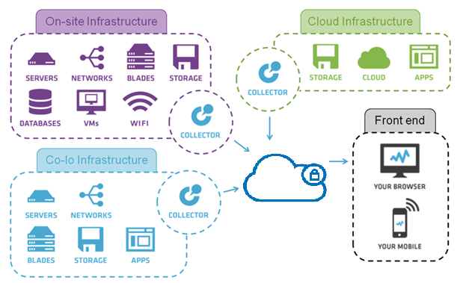

2. Logging into your account
In this support article, we walk you through logging into your account for the first time.

Download the iManage Google Play Store or Apple Store
Login with the registered user account or Sign up with any social account.

Logging into iManage

If it is your very first time accessing your IManage account and Sign up with any a valid social email ID.

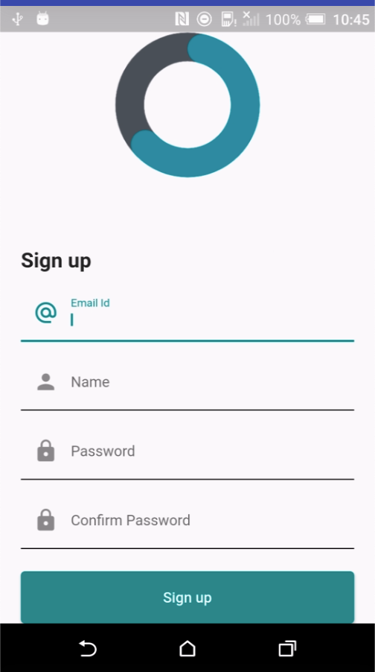

  - Future Logins
For future logins, a valid username and password is needed (either the credentials used when initially logging in or those that were subsequently assigned to a new user account).

Locking and unlocking the Mobile APP.

  - Forgotten Password

In the case of a forgotten password, click the I forgot my password! link located in the lower left of the login screen. You will be prompted to enter an email containing a temporary password reset URL will then be sent to that username’s associated email account.

Note: The password reset URL will only remain active for 15 minutes.

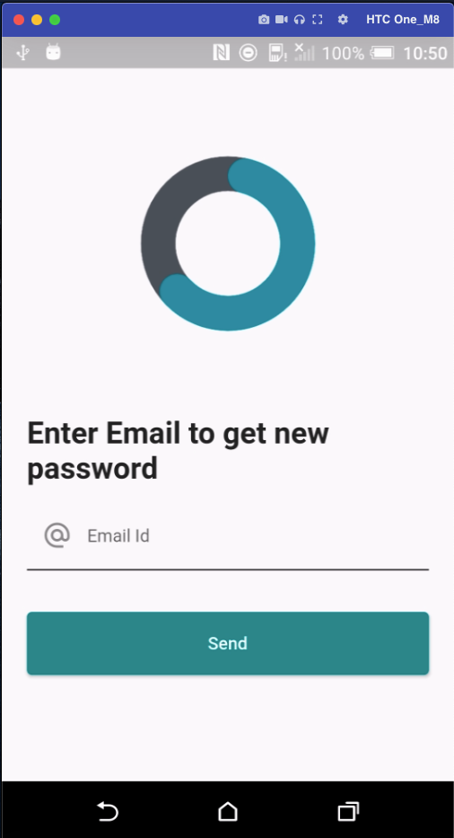

Adding servers into monitoring Dashboard.

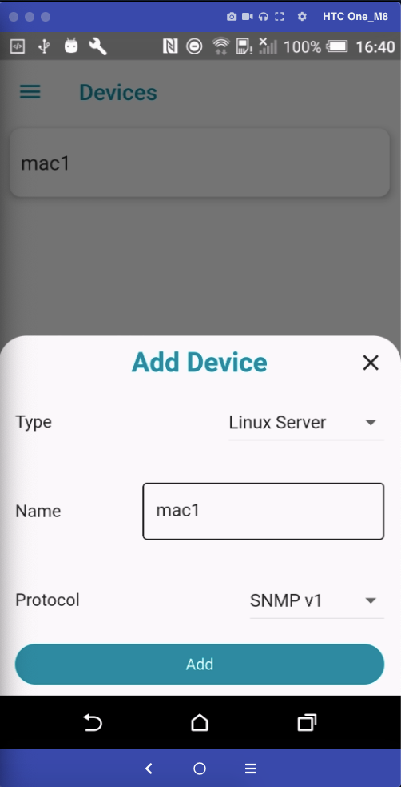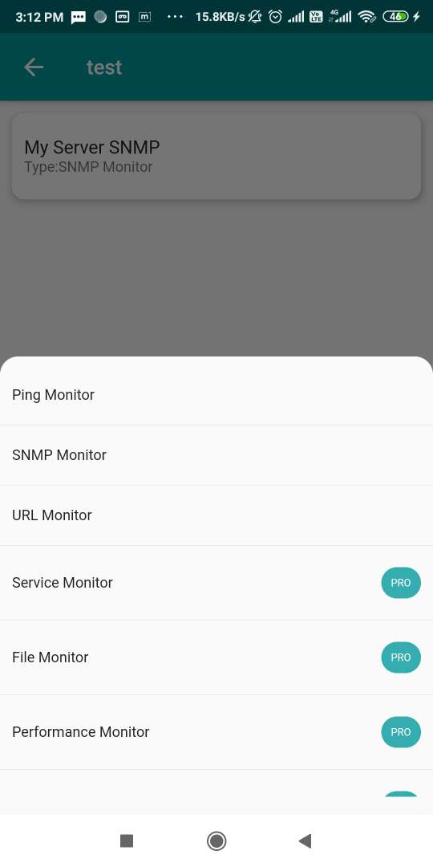

Real-time-server performance monitor dashboard

iManage, the trusted server monitor tool, out-of-the-box offers various system performance monitoring features such as CPU monitoring, memory monitoring, Disk monitoring up to a minute interval. It provides a graphical view of these metrics to monitor and measure server performance, in real-time. It also allows you to drill down to a particular time interval to understand more about the issue and take necessary actions proactively. Utilizing this, you can fix issues before it causes serious damage to your business. For monitoring the availability and performance of other networking devices like switches, routers, storage devices, printers, and more, network monitoring tools are used. You can also obtain a holistic view of the status of your servers instantly by creating custom server monitoring dashboard such as Windows server monitoring dashboard, Linux server monitoring dashboard, server performance monitoring dashboard, etc.

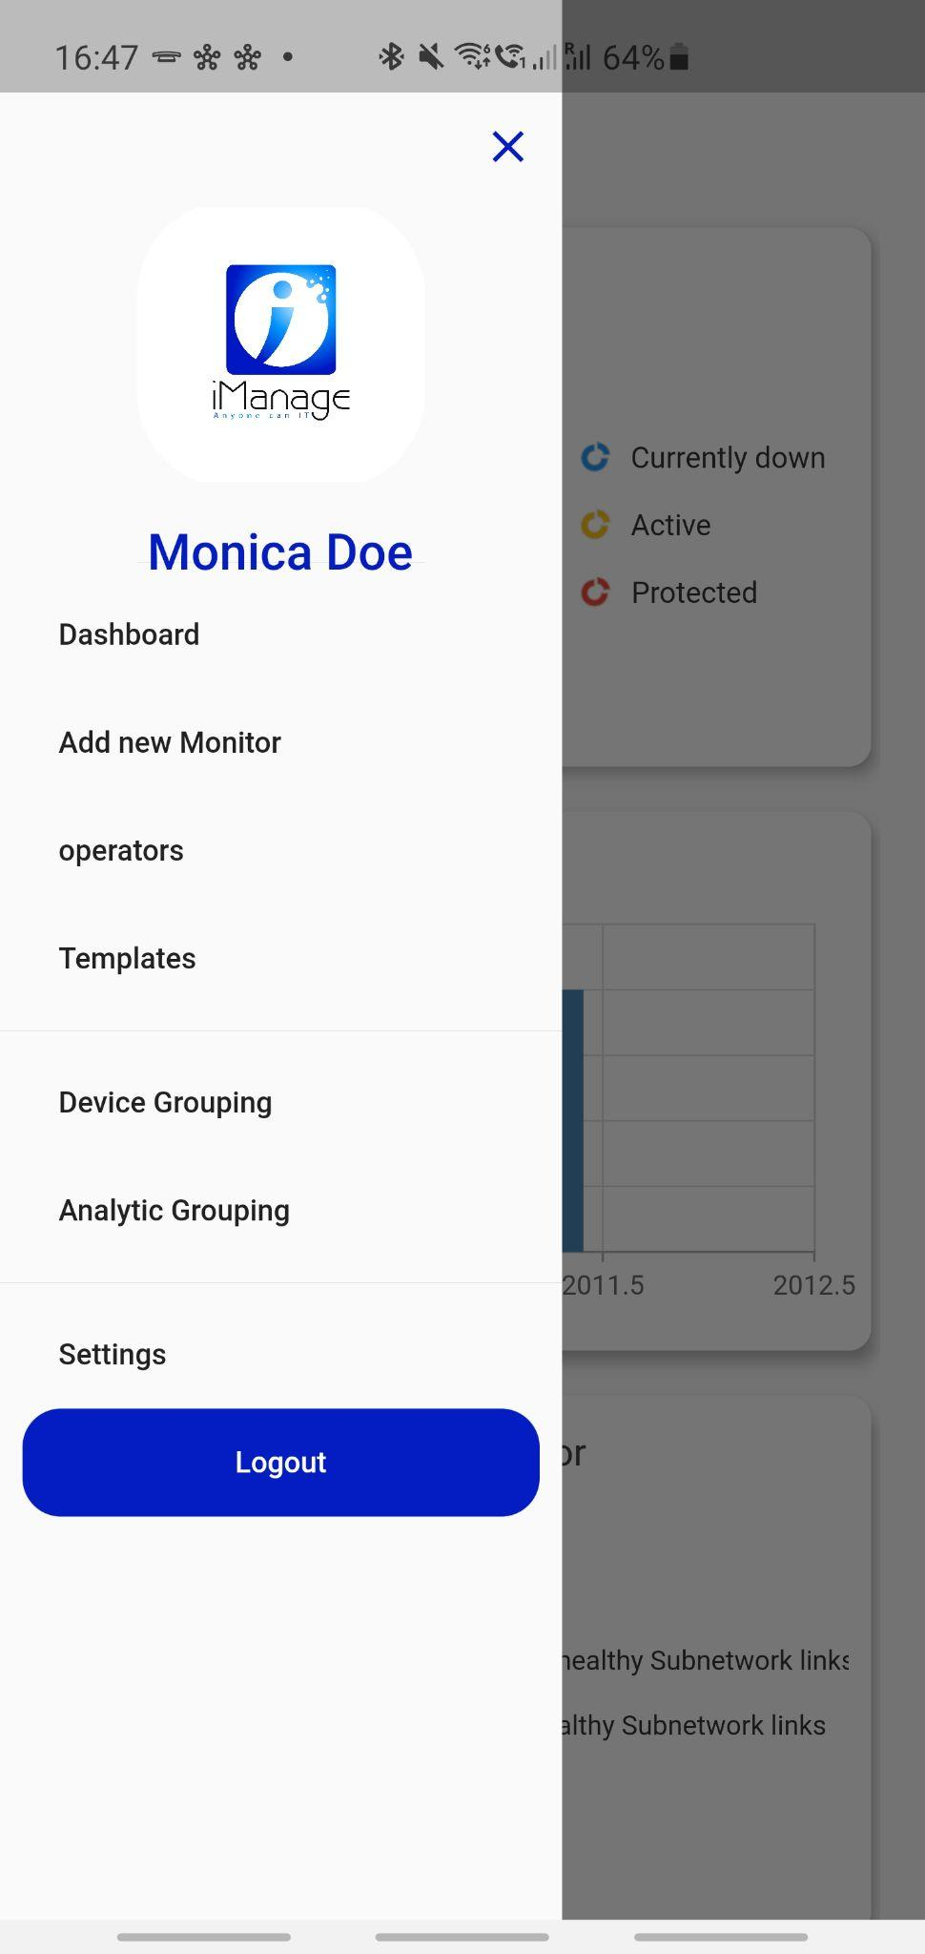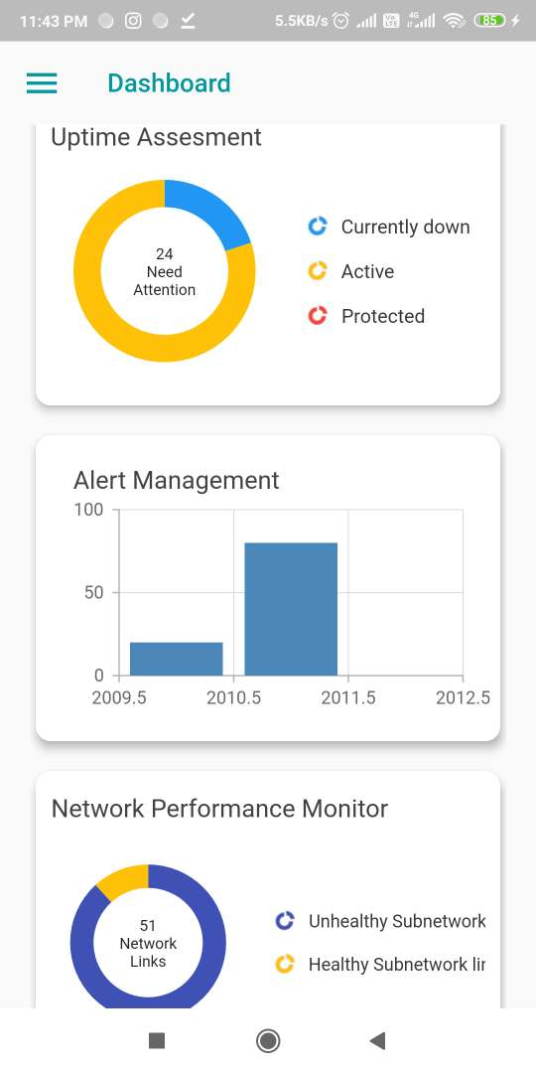

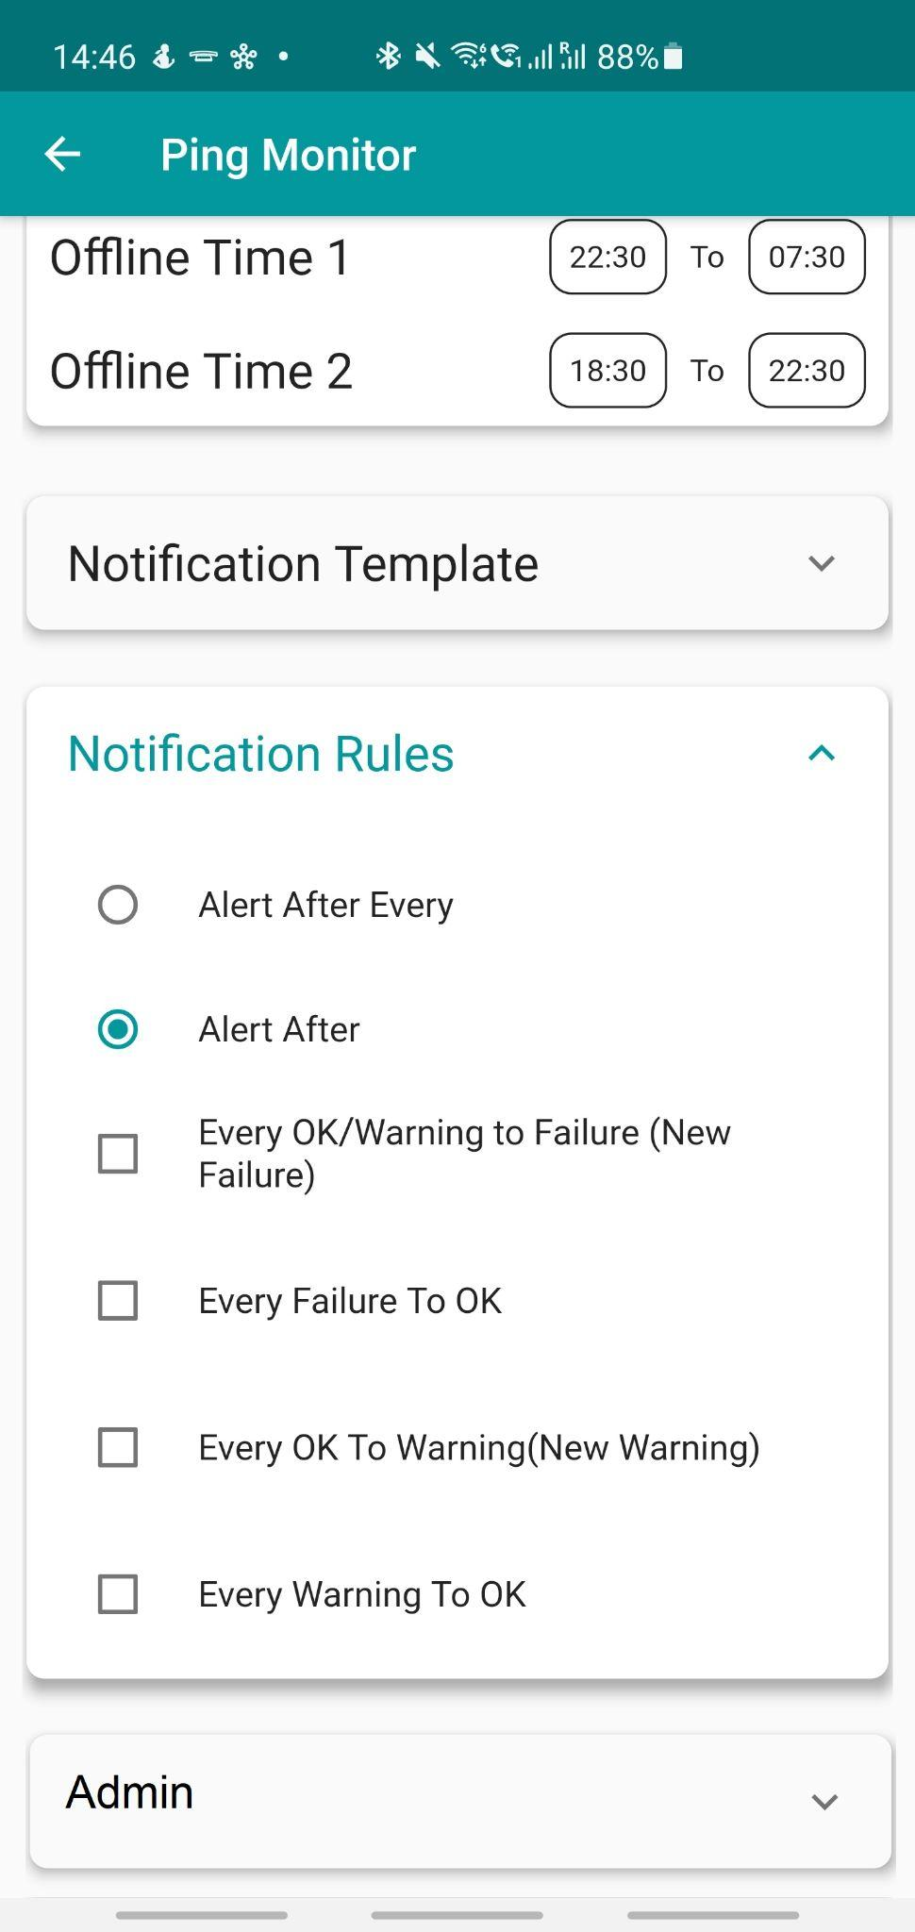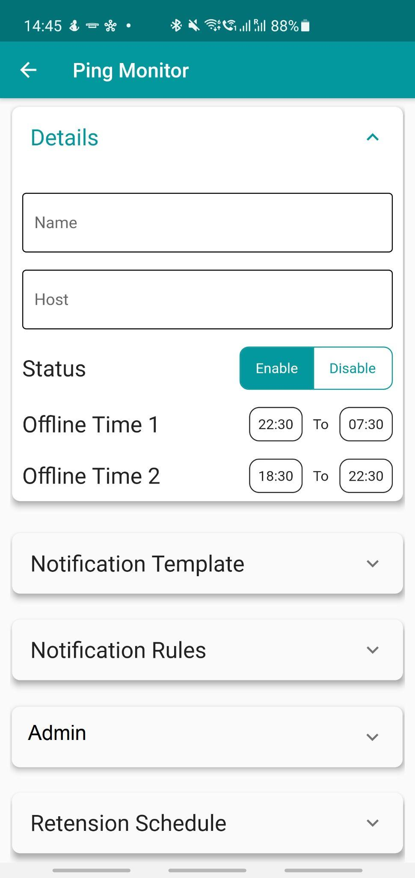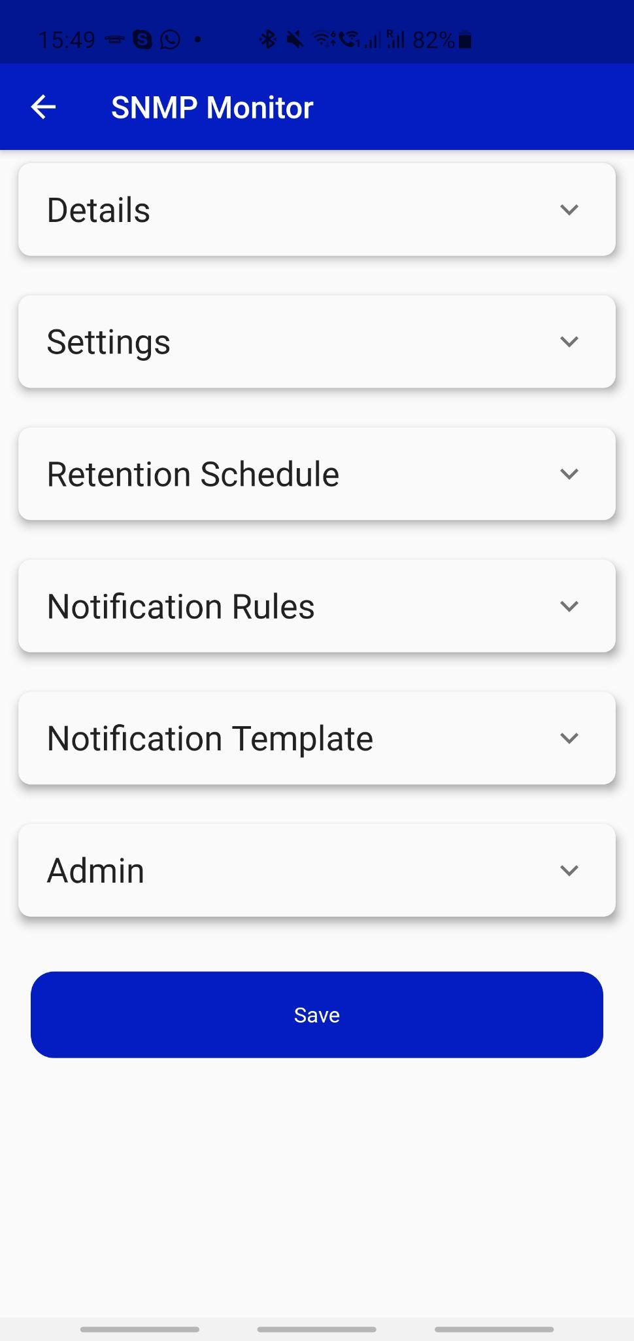

  - Automating system performance:

Using AI (Automation Interface) the below actions can be performed.

- List the process consuming high CPU or memory through the dashboard. Stop or terminate the process to regain the utilization.
- Start or stop the services causing high utilization.
- Review date consuming the disk utilization. Initiate a disk cleanup based on the file extensions.
- Review logs for errors based on a search string.

Monitoring server availability and health

IManage, one among the leading server performance monitoring tools, offers several out-of-the-box features such as server availability monitoring and more than 300 performance metrics such as page read/write, processor queue length, free physical memory, disk I/O, process queue length through SNMP and WMI protocols. iManage’s server uptime monitoring feature helps you keep tabs on the availability of all physical and virtual servers 24x7. You can monitor critical performance metrics every minute and detect performance issue at its early stage by using powerful features like server monitoring dashboards. Apart from the default monitors, you can also create your own custom monitors using server monitoring dashboard template. All the collected data of the server performance metrics are stored in the database for detailed analysis and for creating monthly and yearly performance reports.

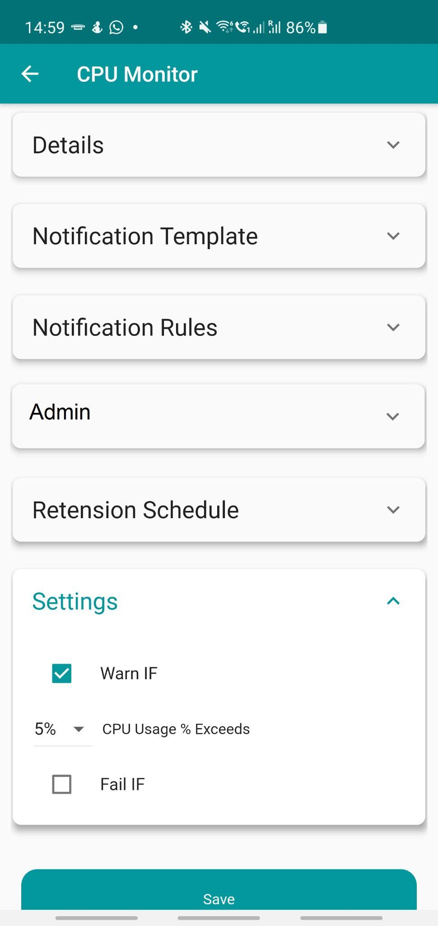

  - Automating system Availability:

Using AI (Automation Interface) the below actions can be performed.

- Check the server uptime report.
- Initiate a server restart.

Web server monitoring and application performance

When it comes to business-critical applications, you don’t want to leave any stone unturned. iManage offers advanced server monitoring services and monitors processes and Windows services, with most of the discovery and monitoring done out-of-the-box. iManage can even detect attempted security break-ins over your application servers (login failures due to bad passwords, account lockouts, failed attempts to access secure files, etc.) by processing Windows Event logs & syslog monitoring.

Services monitoring

At the time of device discovery, iManage discovers all the services running on your Windows & Linux servers and associates’ availability and response time monitors to these. iManage also supports adding monitors for custom services running on TCP port.
  - Automating Service Availability:

Using AI (Automation Interface) the below actions can be performed.

- Check the service status.
- Stop/start the services.

URL and website monitoring

Simply relying on availability and response time (TCP Port) checks won’t help you know if your website has been compromised. IManage allows you to monitor a URL and search for a specific text on the page. When the text is missing you can be immediately alerted, and you get to know in real time that your website has been compromised. iManage’s website monitoring supports HTTP⁄ HTTPs and NTLM Authenticated sites.

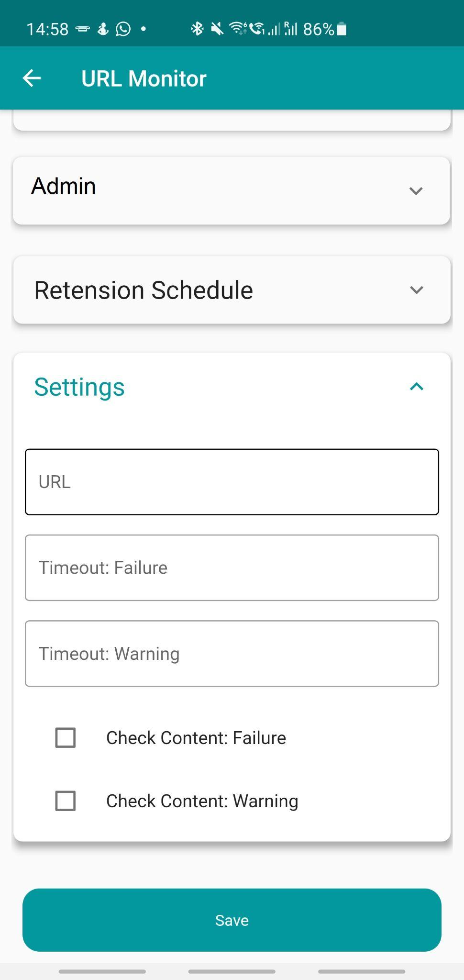

  - Automating Website Availability:

Using AI (Automation Interface) the below actions can be performed.

- Check the URL status.
- Initiate a URL stop/start.
- Initiate IIS or Application pool restart to fix URL issues.
- Review the logs for errors or events for troubleshooting.

